**Building a Test Plan in the NIST Test Case Authoring and Management Tool (TCAMT)**

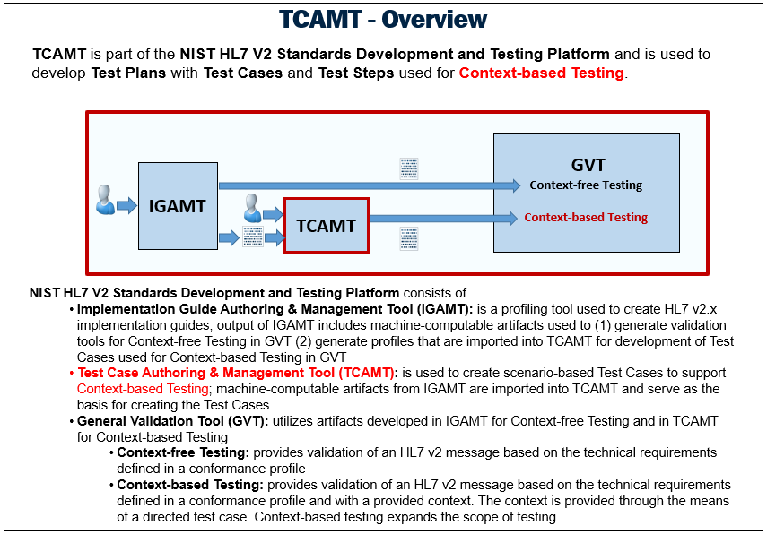

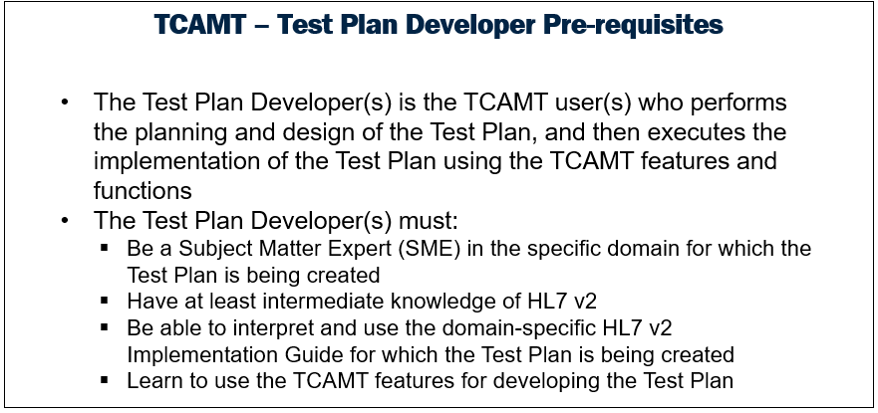

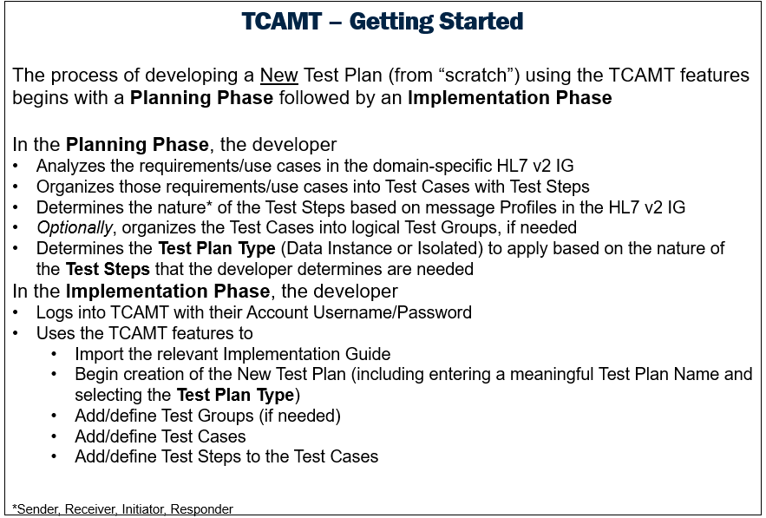

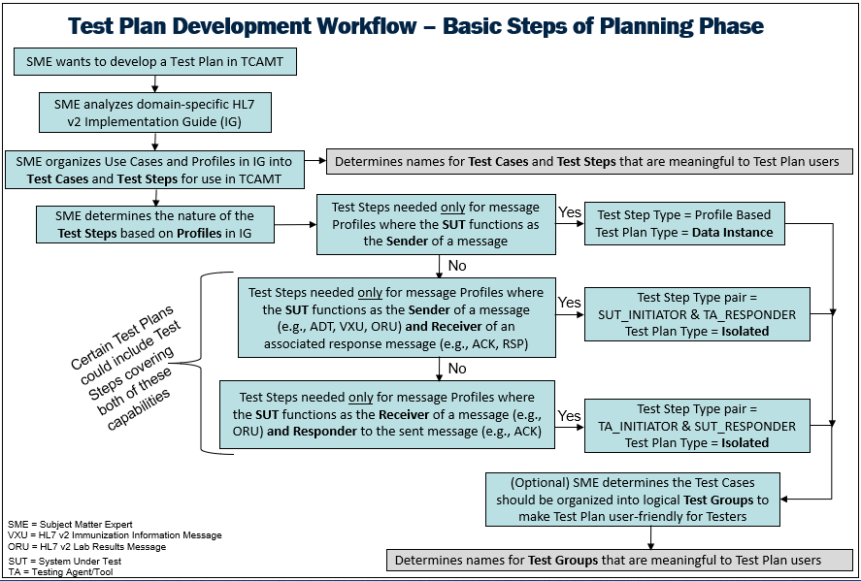

Optionally, Manual Test Step Types also may be included in either Test Plan Type. Manual Test Steps are used to provide testing procedure instructions to the Tester and do not involve any HL7 v2 message validation by the NIST Test Tool. (see TCAMT Introductory Tutorial for details)

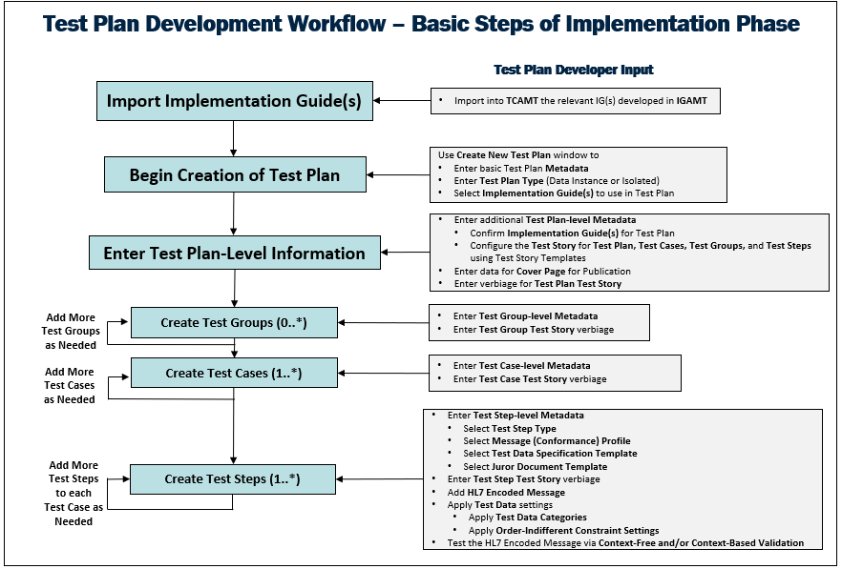

Once the Test Plan is developed in TCAMT, the developer uses a TCAMT function to automatically “push” the Test Plan to the NIST General Validation Tool (GVT) where QA testing of the Test Plan is completed.

DRAFT Template for Organizing/Collecting Test Plan/Test Case Data

# Version #n.n

## DDth MMM, 2020

Immunization Serology Messaging

Test Plan Information for TCAMT

|  |  |
| --- | --- |
| **Test Plan Type**  (Select one) | **Test Step Types Needed**  (Choose all that apply for the **selected** Test Plan Type) |
| ___ Data Instance | ___ Profile Based  ___ Manual |
| ___ Isolated | ___ (Profile Based)TA_INITIATOR  ___ (Profile Based)TA_RESPONDER  ___ (Profile Based)SUT_INITIATOR  ___ (Profile Based)SUT_ RESPONDER  ___ SUT_MANUAL  ___ TA_MANUAL |

Test Plan developer must create at least the following verbiage:

* Name of Test Plan
* Name of Domain for Test Plan (e.g., “Immunization”)
* Description for Test Plan (e.g., intended use, nature of the Test Groups (if any), Test Cases, and Test Step)
* Title, Sub-title, Version #, Date for Test Plan Cover Page
* Description for Test Groups (if any)

Test Data for Immunization Test Tool

for a Serology Test Case

(examples are provided)

# Name of Test Case:

**EXAMPLE**: IZ-01_Serological_Evidence_of_Immunity

# Test Case Test Story

#### Description

#### EXAMPLE

#### A 19-year-old female is seen at a clinic for a checkup. No vaccine is administered on this visit. The clinician enters history of measles infection data into the EHR, including the serological evidence of immunity for measles and transmits it to the IIS.

#### Comments

**Example**

This Test Case provides an example of clinical encounter that could take place in…

#### Pre-Condition

**Example**

No PreCondition

#### Post-Condition

**Example**

No PostCondition

#### Test Objectives

**Example**

This test case assesses the ability of the HIT Module to enable recording of evidence of immunity and create an immunization message containing these data.

#### Evaluation Criteria

N/A

#### Note

**Example**

No note.

# Name of Test Step:

**EXAMPLE**: IZ-1.1_SEOI_Send_VXU_V04_IZ22_R1.0

# Type of Test Step:

**EXAMPLE**: (Profile Based)SUT_INITIATOR

# Test Step Test Story

#### Description

#### EXAMPLE

#### A 19-year-old female, Hazel Jackson goes to the West Clinic for a checkup. A clinic staff member collects basic patient demographic information including name, date of birth and administrative sex. A clinic provider, Vivian Jordan reviews the patient's medical and vaccination history and determines that Hazel has a history of measles infection, which is an indication for serological evidence for measles.  No vaccine is administered on this visit.  The clinician Spencer Tyler Hill (ID 9914) enters the data into the EHR, including the serological evidence of immunity for measles and transmits it to the IIS.

#### Comments

**Example**

This Test Case provides an example of clinical encounter that could take place in…

#### Pre-Condition

**Example**

No PreCondition

#### Post-Condition

**Example**

No PostCondition

#### Test Objectives

**Example**

Output a VXU message in HL7 v2 containing immunization evidence of immunity data for the patient.

#### Evaluation Criteria

**Example**

Message Validation Report

[If this Test Step is for ACK message, the Evaluation Criteria could state “The acknowledgement message is consumed by the system responsible for the content of the administration message without error as per Juror Document.”]

#### Note to Testers

**Example**

For new administration messages, the vaccine is communicated using NDC codes in RXA-5 (Administered Code). For a given vaccine, one or more NDC codes may be appropriate to message. For this reason, RXA-5.1 is categorized as "Value - Test Case Fixed List" and allows for multiple valid values. The Message Content and Example Message data contain a single representative valid NDC code for example purposes.

# Example Test Message

MSH|^~\&|NISTEHRAPP|NISTEHRFAC|NISTIISAPP|NISTIISFAC|20161120142514-0500||VXU^V04^VXU_V04|NIST-IZ-11.1_ADC_Send_VXU_V04_IZ22_R1|P|2.8.2|||NE|AL|||||IZ22r1.0^CDCPHINVS|NISTEHRFAC^CDCPHINVS|NISTIISFAC|NISTIISFAC

PID|1||14445^^^NIST-MPI-1^MR||Jackson^Hazel^^^^^L|Willis^^^^^^M|19900312|F^Female^HL70001||2131-1^Other race^CDCREC|2501 Duval Street^^Austin^TX^78704^USA^P||^PRN^PH^^^512^5559812|||||||||2186-5^Not Hispanic or Latino^CDCREC||N|1|||||N

PD1|||||||||||07^Recall only - no calls^HL70215|N|20091120|||A^Active^HL70441|20091120|20091120

OBX|1|CWE|75505-8^Disease with serological evidence of immunity^LN|1|371111005^Measles immune^SCT||||||F|||20091120

ORC|RE|3598^NIST-AA-IZ-2|94560^NIST-AA-IZ-2|||||||9914^Hill^Spencer^Tyler^^^^^wcEHR^L^^^PRN||724^Jordan^Vivian^Sarah^^^^^wcEHR^L^^^MD|||||wcEHR^West Clinic^HL70362

RXA|0|1|20091120|20091120|998^No vaccine administered^CVX|999||||||||||||||NA

# Name of Manual Test Step:

**EXAMPLE**: IZ-1.2_Enter Initial Demographic Data for New Patient FIRSTNAME LASTNAME

# Type of Test Step:

**EXAMPLE**: SUT_MANUAL

# Manual Test Step Test Story

#### Description

#### EXAMPLE

#### The EHR vendor loads demographic data for FIRSTNAME LASTNAME.

#### Comments

**Example**

Set-up step evaluating EMR functions for capturing and storing patient demographic data. There is no transaction associated with this test step.

#### Pre-Condition

**Example**

No PreCondition

#### Post-Condition

**Example**

#### The EMR has recorded all of the demographic in the record created for FIRSTNAME LASTNAME.

#### Test Objectives

**Example**

#### ****Register New Patients:****The system must allow a user to enter distinguishing information about patients so that providers can uniquely identify patients who have similar sounding names or other similar identifying information. For example, twins living in the same household will have similar dates of birth, addresses, and may have similar names. EHRs or other clinical software must be able to store information to successfully match with patients in immunization registries, if the information is available. The information includes the mother's maiden name, whether the patient was part of a multiple birth, and the order of the multiple birth. This information allows the provider to correctly identify the patient and also helps assure a match when the EHR send the patient's information to external systems such as an immunization registry.

#### Evaluation Criteria

**Example**

Vendor successfully records all demographic data provided, and in particular (Mother's maiden name, multiple birth, birth order), with all required attributes indicated by [Y], The code values are not expected to be displayed to the user, but it is expected that the value selected has the identified meaning, and it is expected that the system will use the specified coded value when the attribute is conveyed in later transaction messages.

For systems that document VFC eligibility at the patient level: VFC Eligible

|  |  |  |
| --- | --- | --- |
| Patient ID (previously listed as "Medicaid Number") | Vendor supplied | Y |
| Patient ID: Assigning Authority ID (i.e., owning source)/Facility Name | NAME OF PROVIDER FACILITY | Y |
| Patient ID: Type (e.g., medical record number, IIS ID) | Vendor supplied | Y |
| Patient Name: First | FIRSTNAME | Y |
| Patient Name: Middle | MIDDLENAME | Y |
| Patient Name: Last | LASTNAME | Y |
| Patient Date of Birth | MM/DD/YYYY | Y |
| Birth Time | HH:MM5 | N |

#### Note to Testers

**Example**

Publicity Code is included in order to support documentation of communication method. If the HIT Module does not support this attribute, the result for this step may indicate pass, but the lack of support should be documented as a notable exception.

The date/time of birth for a twin includes birth time to aid in distinguishing the birth order for multiple births. Since this patient is not a multiple birth, the vendor can pass with notable exception if the birth date/time does not include precision of birth time. The notable exception should document the lack of support for birth time.